Comparison of Thermo-Physical Properties between
Sn, Li, and Pb-Li

The thermal conductivity, electrical resistivity, surface tension, dynamic viscosity vapor pressure, and density of Sn, Li, and Pb-17Li are summarized in the following figures.

Thermal Conductivity of Coolants
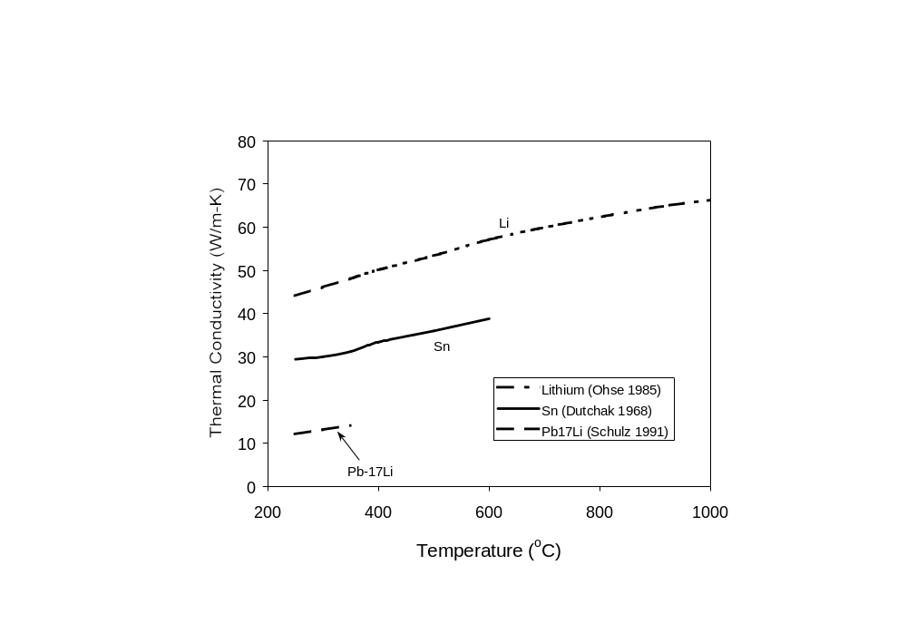
Figure 1: Comparison of thermal conductivity of Sn, Li, Pb-17Li, and Sn-25Li.

References:
- B. Schulz, Fusion Eng. Design 14 (1991) 199.
- R. W. Ohse (Ed.) Handbook of Thermodynamic and Transport Properties of Alkali metals, Inter. Union of Pure and Applied Chemistry Chemical Data Series No. 30. Oxford: Blackwell Scientific Publ., 1985, pp. 987.
- Ya. I. Dutchak, V. P. Osipenko, P. V. Panasyuk, Izv, Vyssh. Zavedenii, Fiz, 1968, No. 10, p. 154/C, C.A. 70[1969] No. 61918.

High-Temperature Thermal Conductivity of Sn
The rule of mixtures is used to estimate the thermal conductivity of Sn-25Li. High-temperature (>600°C) thermal conductivity data for Sn is estimated using the Wiedeman-Franz equation, which relates the thermal conductivity of metals to their electrical resistivity:
k_{th} = LT/ρ + k_{o} (W/mK)
where L is the Lorentz constant (2.4410⁻⁸ W-Ω/K²), ρ is the electrical resistivity (Ω-m), and k_{o} is constant in W/mK. The best fit of the Wiedeman-Franz equation to the measured Sn data is with k_{o} = 0 W/mK (see Figure below).

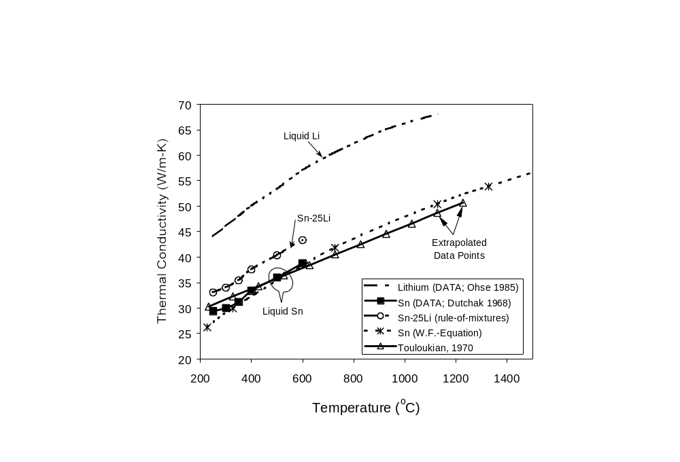
Figure 2: Extrapolated thermal conductivities of liquid Sn and Sn-25Li..

References:
- R. W. Ohse (Ed.) Handbook of Thermodynamic and Transport Properties of Alkali metals, Inter. Union of Pure and Applied Chemistry Chemical Data Series No. 30. Oxford: Blackwell Scientific Publ., 1985, pp. 987.
- Ya. I. Dutchak, V. P. Osipenko, P. V. Panasyuk, Izv, Vyssh. Zavedenii, Fiz, 1968, No. 10, p. 154/C, C.A. 70[1969] No. 61918.
- Y. S. Touloukian et al., “Thermal conductivity: metallic elements and alloys,” New York, IFI/Plenum, 1970.

Electrical Resistivity

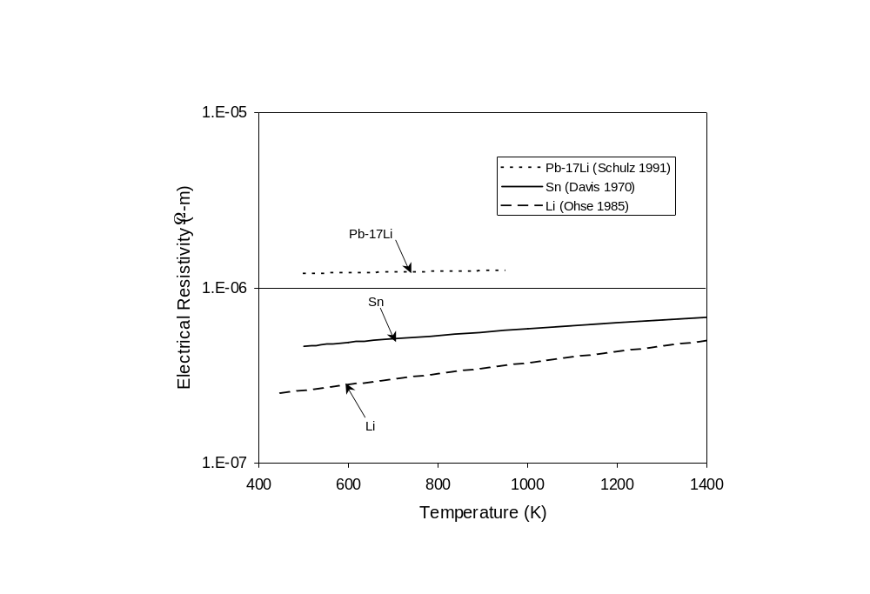
Figure 3: Electrical resistivity of liquid Sn, Pb-17Li, and Li.

References:
- B. Schulz, Fusion Eng. Design 14 (1991) 199.
- H. A. Davis, J. S. L. Leach, Phys. Chem. Liquids 2 (1970) 1/12, 5.
- R. W. Ohse (Ed.) Handbook of Thermodynamic and Transport Properties of Alkali metals, Inter. Union of Pure and Applied Chemistry Chemical Data Series No. 30. Oxford: Blackwell Scientific Publ., 1985, pp. 987.

Surface Tension

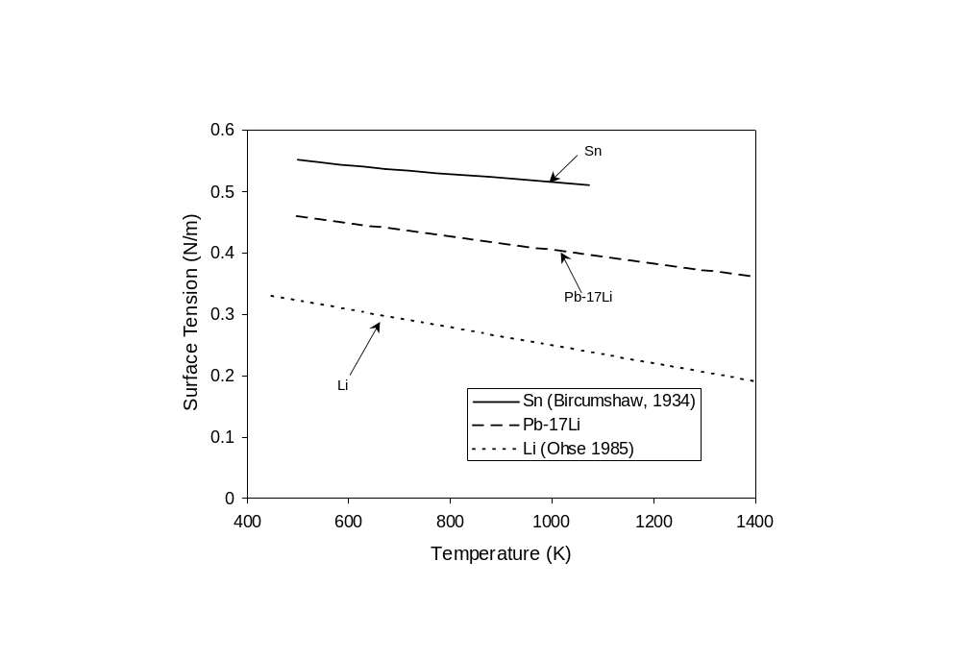
(Schulz, 1991)
Figure 4: Comparison of surface tension of liquid coolants

References:
- L.L. Bircumshaw, Phyl. Mag. 17 No. 7 (1934) 181/91, 186.
- B. Schulz, Fusion Eng. Design 14 (1991) 199.
- R. W. Ohse (Ed.) Handbook of Thermodynamic and Transport Properties of Alkali metals, Inter. Union of Pure and Applied Chemistry Chemical Data Series No. 30. Oxford: Blackwell Scientific Publ., 1985, pp. 987.

Dynamic Viscosity
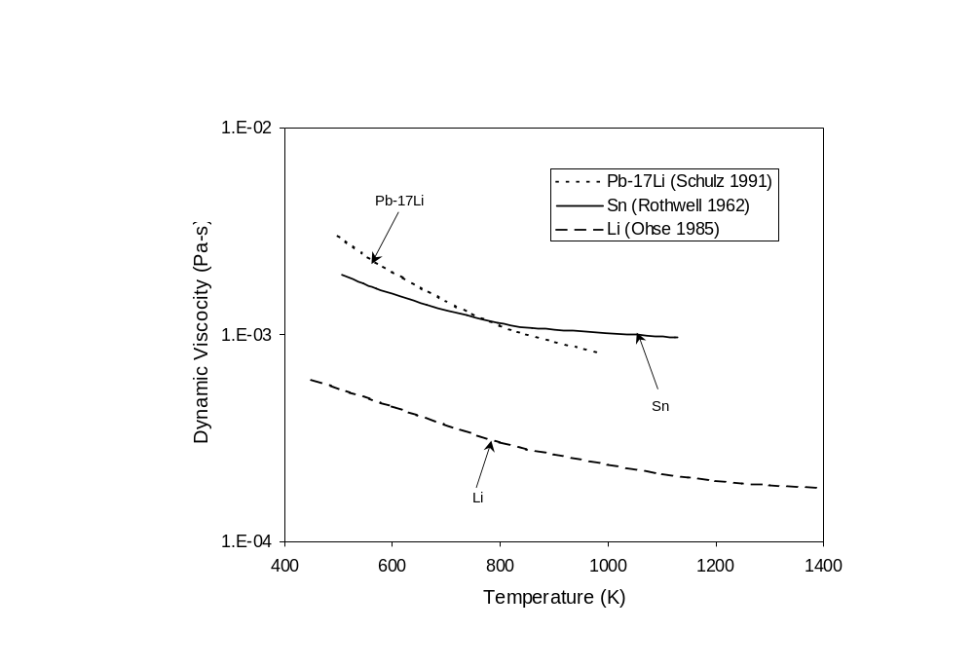
Figure 5: Comparison of the dynamic viscosity of liquid coolants.

References:
- B. Schulz, Fusion Eng. Design 14 (1991) 199.
- R. W. Ohse (Ed.) Handbook of Thermodynamic and Transport Properties of Alkali metals, Inter. Union of Pure and Applied Chemistry Chemical Data Series No. 30. Oxford: Blackwell Scientific Publ., 1985, pp. 987.
- E. Rothwell, J. Inst. Metals 90 (1962) 38/94, 392.

Vapor Pressure
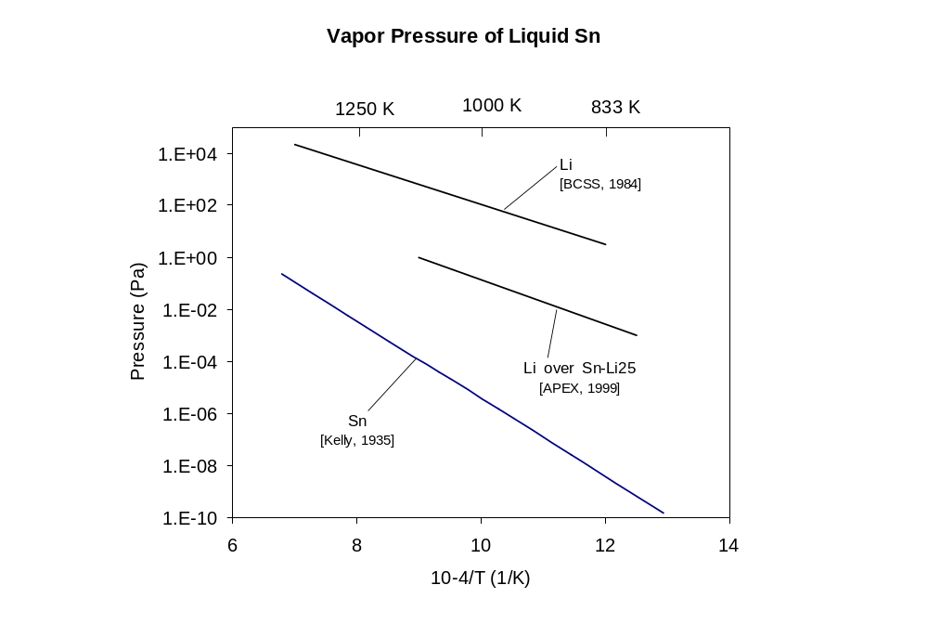
Figure 6: Comparison of the vapor pressure of liquid coolants.

References:
- K. K. Kelly, U.S. Bur. Mines Bull. Nr. 383 (1935) 1/132, 105.
- M. Abdou, et al., “On the Exploration of Innovative Concepts for Fusion Chamber Technology: APEX Interim Report,” University of California School of Engineering and Applied Science, UCLA-ENG-99-206, Nov. 1999.
- M. Abdou, et al., “ Blanket Comparison and Selection Study Final Report,” Argonne National Laboratory Report, ANL/FPP-84-1, Vol. 2.,1984

Density of Liquid Coolants
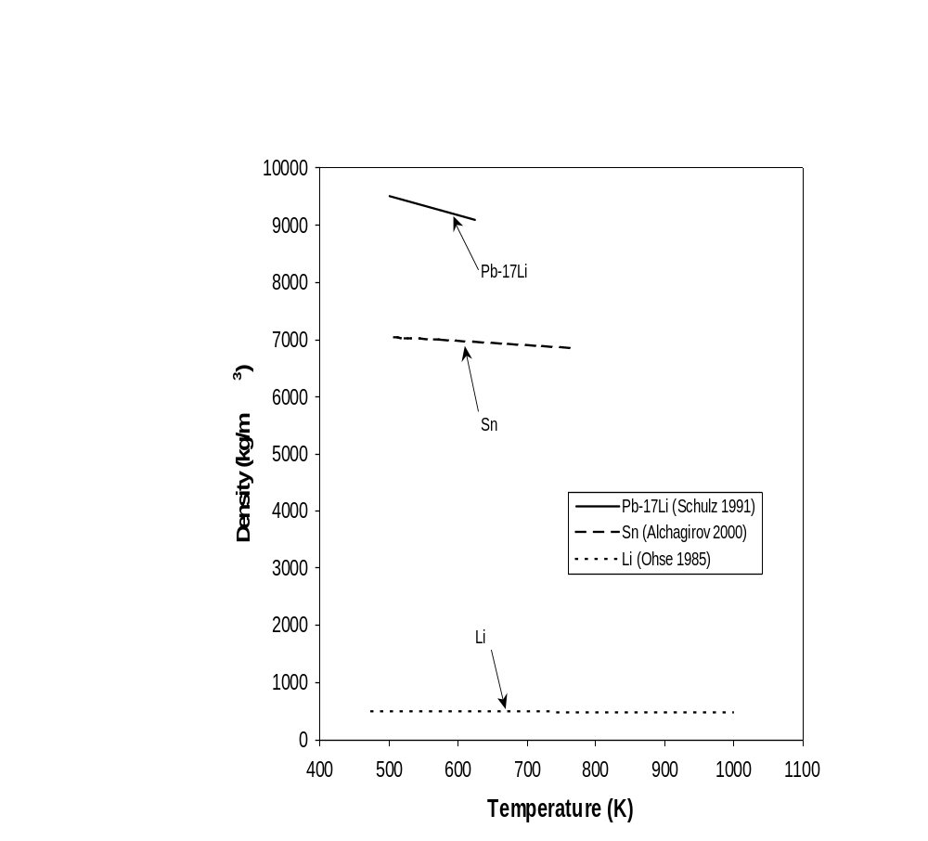
Figure 7: Comparison of the density of liquid coolants.

References:
- B. Schulz, Fusion Eng. Design 14 (1991) 199.
- R. W. Ohse (Ed.) Handbook of Thermodynamic and Transport Properties of Alkali metals, Inter. Union of Pure and Applied Chemistry Chemical Data Series No. 30. Oxford: Blackwell Scientific Publ., 1985, pp. 987.
- B. B. Alchagirov, A. M. Chochaeva, “Temperature dependence of the density of liquid tin,” High Temperature 38: (1) 44-48, JAN-FEB 2000

Density of Liquid Sn-Li Mixtures
The rule of mixtures is used to estimate the density of liquid Sn-Li as a function of volume percent at 500°C.
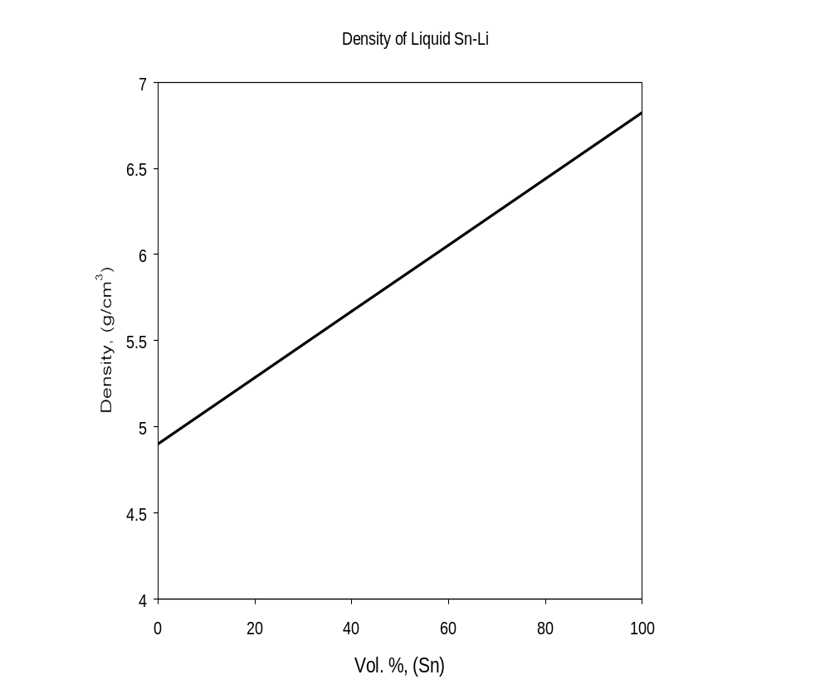
Figure 8: Estimated density of liquid Sn-Li at 500°C.

